Invitation to an
International Leadership Training
for Young Professionals

If you represent a Rotary club that wish to contribute to good future leadership by promoting a young leadership talent or if you are that young talented professional and wish to

- gain more self-confidence and awareness of your capabilities as a leader
- get an understanding of the major tools for successful leadership
- get an understanding of differences and similarities in leadership styles and cultures in different parts of the world.

For the10th time !
- acquire a international network of future leaders
- get an understanding of Rotary International values and ethical standards
- get a personal mentor in your sponsoring Rotary club.

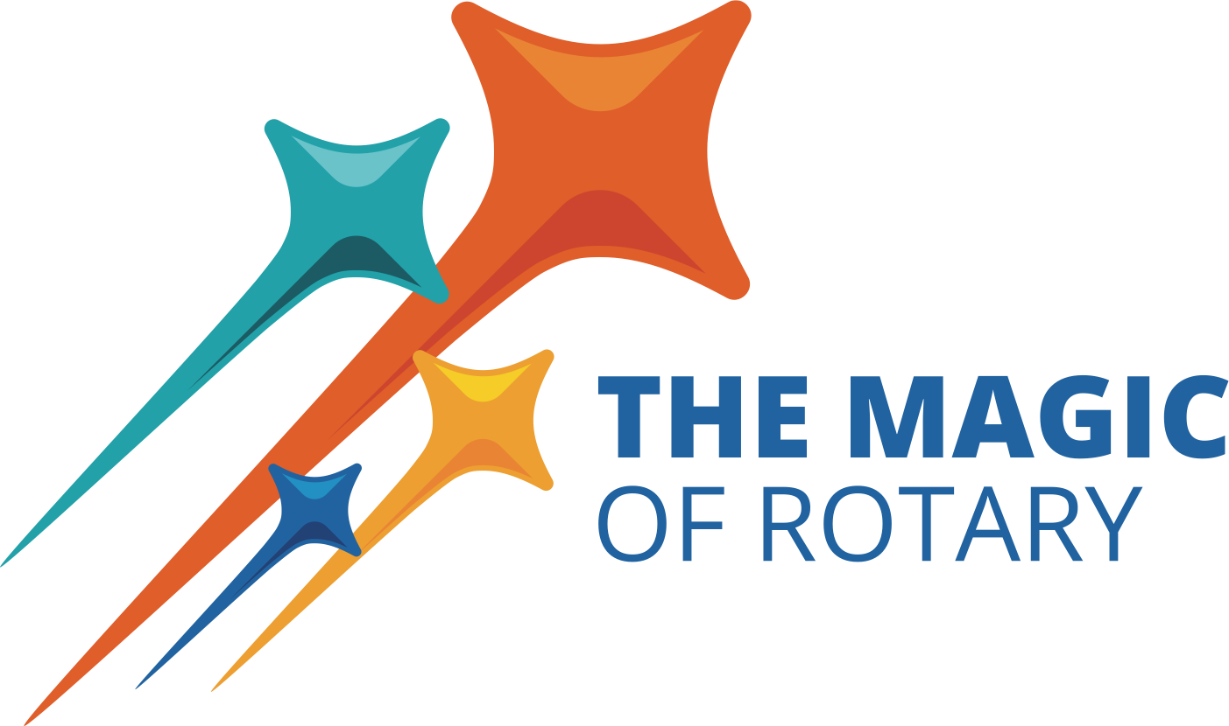
Go to intrylazone1718.org and read more and sign up for this challenging, unique and very successful training that will be carried out in Gdansk 13-15 September 2024.

